|  |  |
| --- | --- |
| C:\Users\tiffanym\AppData\Local\Microsoft\Windows\Temporary Internet Files\Content.Outlook\L1RVHA3J\Bourque_Logistics_Master_Logo (5).png | **Diverting an Empty Railcar**  **RAILTRAC®**  **Revision Number 1**  **2/24/2017** |

Once logged into RAILTRAC, click on the Main tab. Then, select Shipments, and Edit Shipments.

A Get Data For Edit Shipments box will open. Enter the car to be diverted in the Car No. field and click OK.  
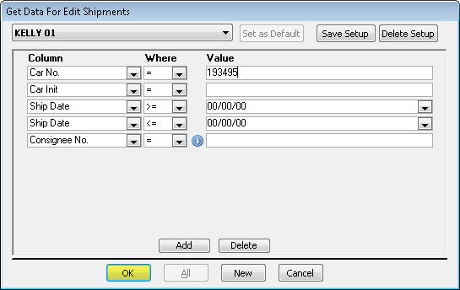

The Edit Shipments screen will open. This screen consists of two sections, the List Detail and the Shipment Detail. When the Edit Shipments screen opens, the List Detail portion of the screen will be activated, as shown by the blue box below. The selected trip will appear in the Shipment Detail portion of the screen.

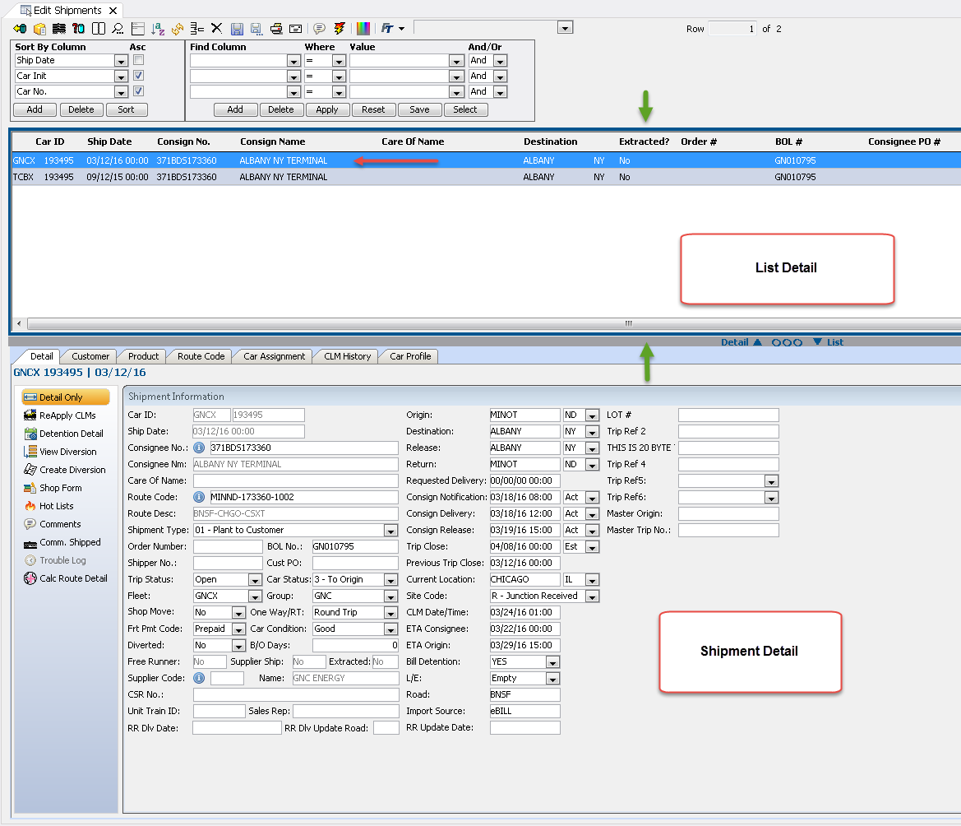

Click anywhere inside the Shipment Detail box to activate the Shipment Detail screen. Then, click Create Diversion.

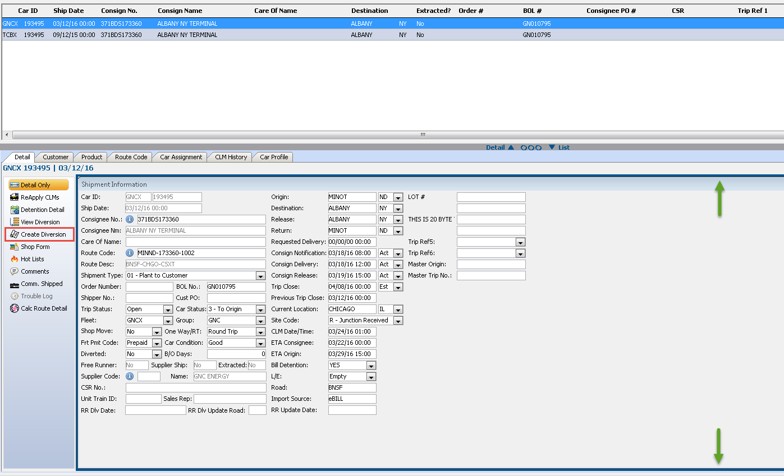

The Add Trip Diversion box will open. To complete this type of diversion in RAILTRAC, the highlighted fields shown below need to be populated. Click CLM History.

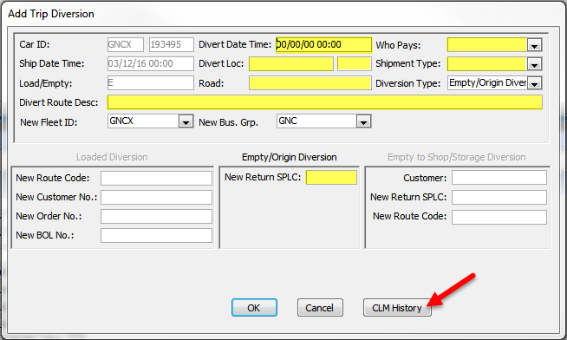

Since car number GNCX193495 was queried, the View CLM History for GNCX193495 box will open. Select the appropriate CLM event from which the diversion should begin and click Add to Diversion.

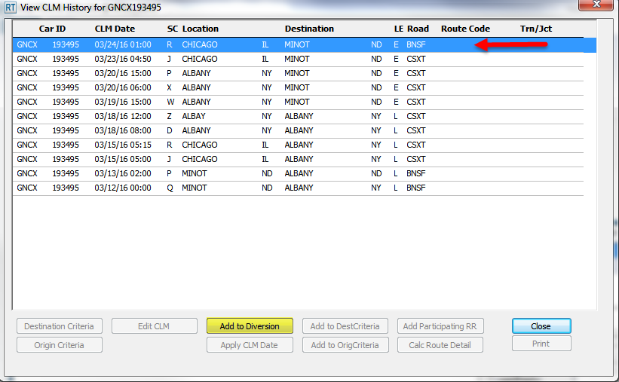

The Add Diversion Criteria box will open informing the user that the diversion criteria has been added successfully for the selected record. Click OK.

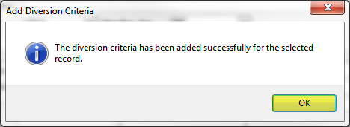

The Add Trip Diversion box will now be populated with some criteria from the selected CLM, including the Divert Date Time, Divert Location, and Road.

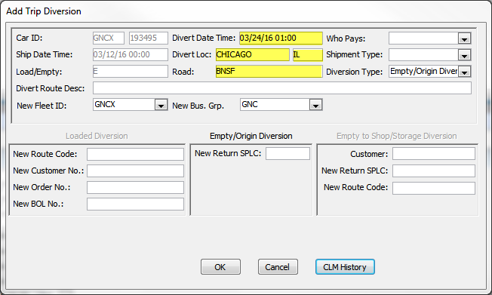

Enter appropriate choices in the fields Who Pays, Shipment Type, and Divert Route Description.

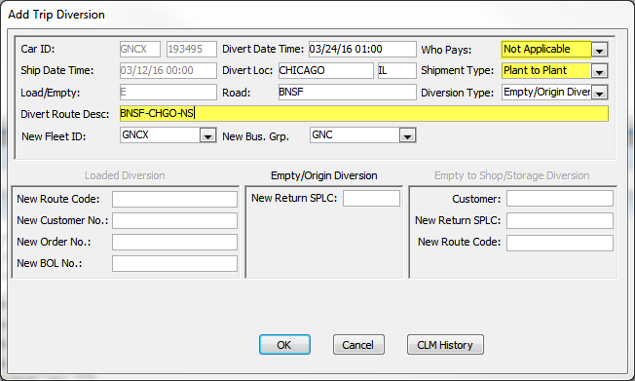

To search for a New Return SPLC, right click the New Return SPLC box.

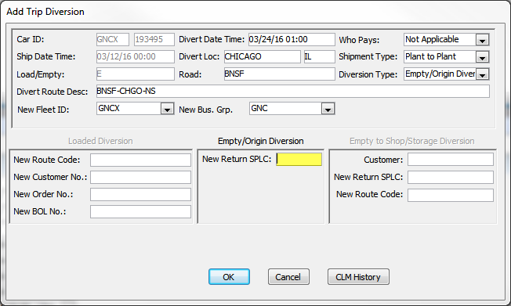

A Find Origin SPLC box will open. Type all or part of the known city criteria and select Search. Then, highlight the return city and click OK.

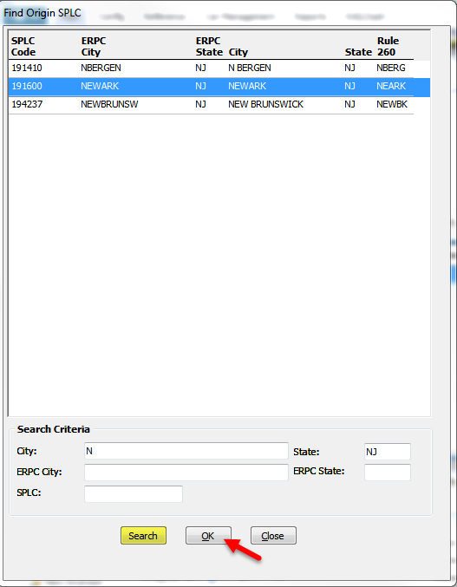

The new Return SPLC will be populated in the Add Trip Diversion box. Click OK.

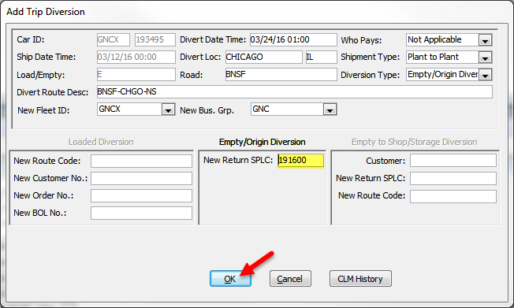

The Trip Diversion Information for Car (GNCX 193495) box will appear summarizing the diversion information.

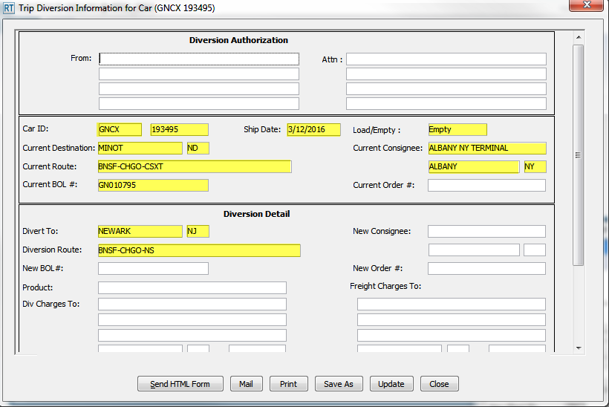

Selecting Update will stamp the diversion with the user’s ID and date and time of diversion. Scroll down in the box to see this information.

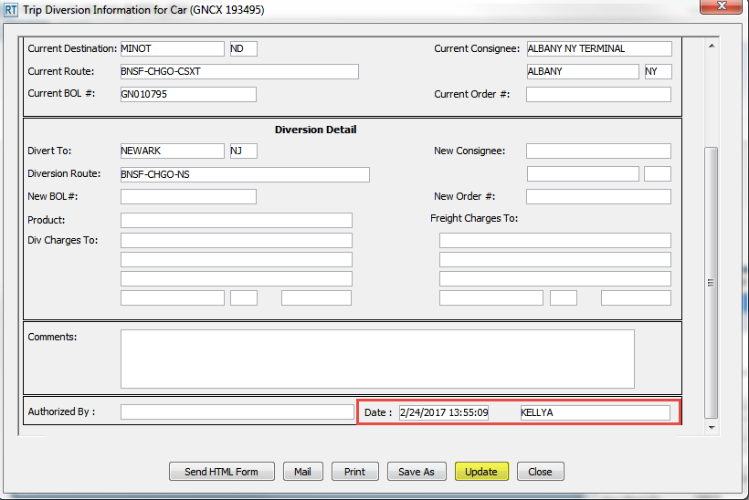

When Close is selected, a Trip Diverted message will appear. Click OK.

